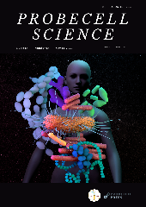 | PROBECELL SCIENCE  Journal homepage: https://probsci.com

Copyright Transfer Form

Paper ID: ………………………….
Paper Title: ..............................................................................................................................................……….
……...........................................................................................................................…………………….……….
This is to certify that the above-titled manuscript comprises original work and truly compiled by me/us and does not contain or include material from other copyrighted sources. Wherever such material has been included, it has proper acknowledgment or/and citation at appropriate places.
I/We have reviewed and approved the final version of the manuscript for publication in Probcell Science. I / We agree that the content of the manuscript will not be copyrighted, or submitted elsewhere, and will not be reproduced in any language elsewhere while acceptance by Probcell Science is being considered.
I/We confirm that the data presented in the manuscript is authentic and, in any circumstances, I/We will be responsible to face any dispute, pointed out by anyone in the future.
I/We hereby assign and transfer copyright and all rights under it to the editor Probcell Science.

Date: ……………………
Place: …………………...

Consent of all author(s):
Sr. No. | Name | Affiliation | Signature

